**Foundations of Computer Science – Exercise 6**



$x_{n+1}=x_{n}-\frac{x_{n}^{2}-N}{{\left(x_{n}^{2}-N\right)}^{'}}= {\frac{1}{2}(x}_{n}-\frac{N}{x_{n}})$

|  |  |
| --- | --- |
| **Address** | **Command** |
| 101 | LOAD 1003 |
| 102 | STORE 1001 |
| 103 | LOAD 1005 |
| 104 | JUMPZERO 1007 |
| 105 | LOAD 1000 |
| 106 | DIVIDE 1001 |
| 107 | STORE 1004 |
| 108 | LOAD 1001 |
| 109 | SUBTRACT 1004 |
| 110 | DIVIDE 1006 |
| 111 | STORE 1001 |
| 112 | LOAD 1005 |
| 113 | SUBTRACT 1003 |
| 114 | STORE 1005 |
| 115 | LOAD 1001 |
| 116 | STORE 1002 |
| 117 | JUMP 103 |

|  |  |
| --- | --- |
| **Address** | **Value** |
| 1000 | n |
| 1001 | xn |
| 1002 | result |
| 1003 | 1 |
| 1004 | N/xn |
| 1005 | 5 |
| 1006 | 2 |

1. a)

|  |  |
| --- | --- |
| **Compiler** | **Interpreter** |
| Execute an entire program at a time | Execute a single line of code at a time |
| Create intermediate object code | No intermediate object code |
| Compilation takes place before execution | Compilation and execution are simultaneous |
| Faster | Slower |
| Require more memory | Require less memory |
| Difficult error detection as all errors are displayed after compilation | Easier error detection as errors of each line are displayed one by one |
| More efficient | Less efficient |

b)

Lexical Analysis:

* Identify the lexical units in a source code
* Classify lexical units into classes like constants, reserved words, and enter them in different tables. It will Ignore comments in the source program
* Identify token which is not a part of the language

Syntax Analysis:

* Obtain tokens from the lexical analyzer
* Checks if the expression is syntactically correct or not
* Report all syntax errors
* Construct a hierarchical structure which is known as a parse tree

Semantic Analysis:

* Helps you to store type information gathered and save it in symbol table or syntax tree
* Allows you to perform type checking
* In the case of type mismatch, where there are no exact type correction rules which satisfy the desired operation a semantic error is shown
* Collects type information and checks for type compatibility
* Checks if the source language permits the operands or not

Intermediate Code Generation:

* It should be generated from the semantic representation of the source program
* Holds the values computed during the process of translation
* Helps you to translate the intermediate code into target language
* Allows you to maintain precedence ordering of the source language
* It holds the correct number of operands of the instruction

Code Optimization:

* It helps you to establish a trade-off between execution and compilation speed
* Improves the running time of the target program
* Generates streamlined code still in intermediate representation
* Removing unreachable code and getting rid of unused variables
* Removing statements which are not altered from the loop

Code Generation: Code generation is the last and final phase of a compiler. It gets inputs from code optimization phases and produces the page code or object code as a result. The objective of this phase is to allocate storage and generate relocatable machine code.

c) Lexical Analysis: Store in symbol table

Syntax Analysis: Store in parse tree.

Code generation: Store in code.

2. E→TE’→FT’E’→**id**T’E’→**id**E’→**id**+TE’→**id**+FT’→**id**+**id**\*FT’→**id**+**id**\***id**
3. Yes as the sentence was parsed based on grammar provided by the parsing table.
4. 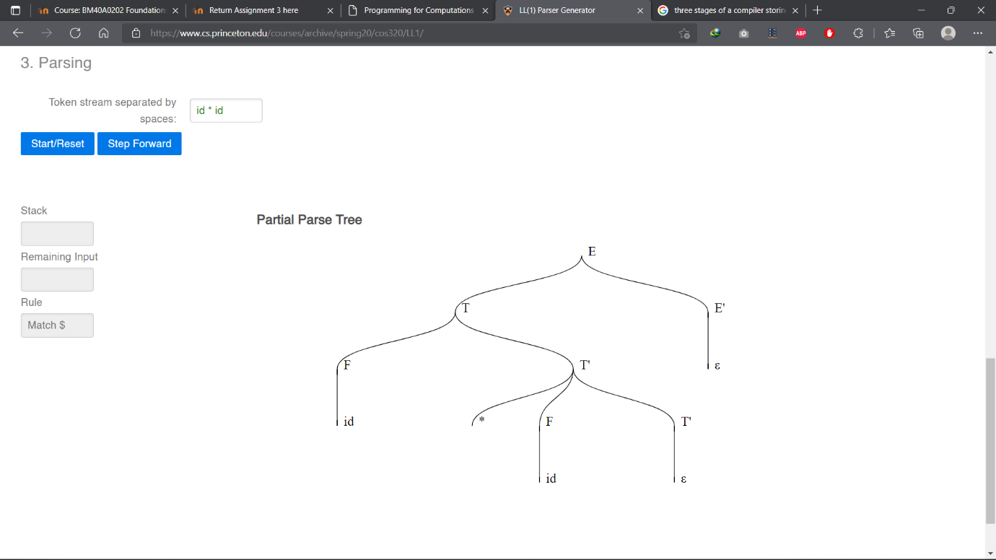**id** * **id**
5. 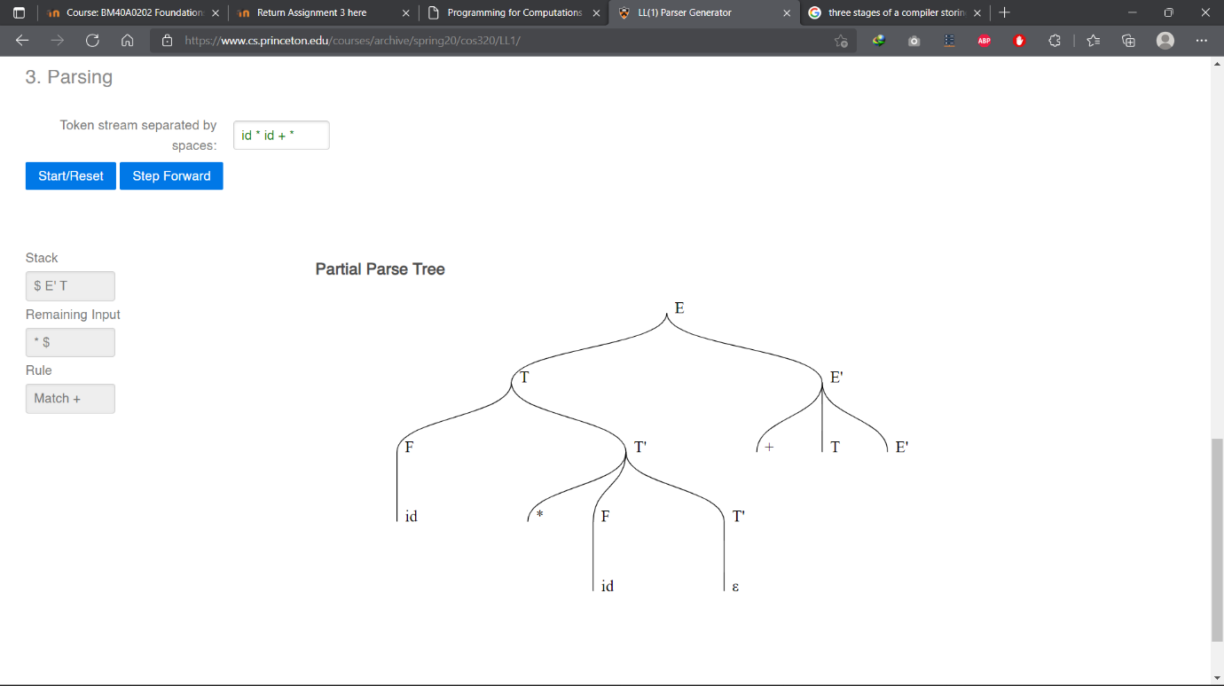Parsing failed:
6. a) Digit+ Other+

b) Tokens that do not follow the Digit – Other – Digit – Other … pattern.